This workflow is similar to -> https://n8n.io/workflows/3100-analyze-landing-page-with-openai-and-get-optimization-tips/
In which I have additionally added Schedule Trigger, HTTP Node and SMTP.
I have designed a workflow to get the new innovations from Science Daily page every week and feed it to AI agent to give me suggestions to implement it which matches with my Profession.

The design contains below nodes
1. Schedule Trigger - to send the innovation suggestion as per AI analysis -> Every 1 week auto trigger

2. HTTP Request – To extract the HTML content of science daily page -> https://www.sciencedaily.com/news/computers_math/information_technology/

3. HTML node – to extact the content of particular elements from HTTP request. Here I extracted <a> node text which only contains the news headings

4. AI agent, Groq Model – to Analyze the news and give the innovations which matched with my profession

5. Send Email SMTP node – to send the AI generated content to my email ID

N8N workflow

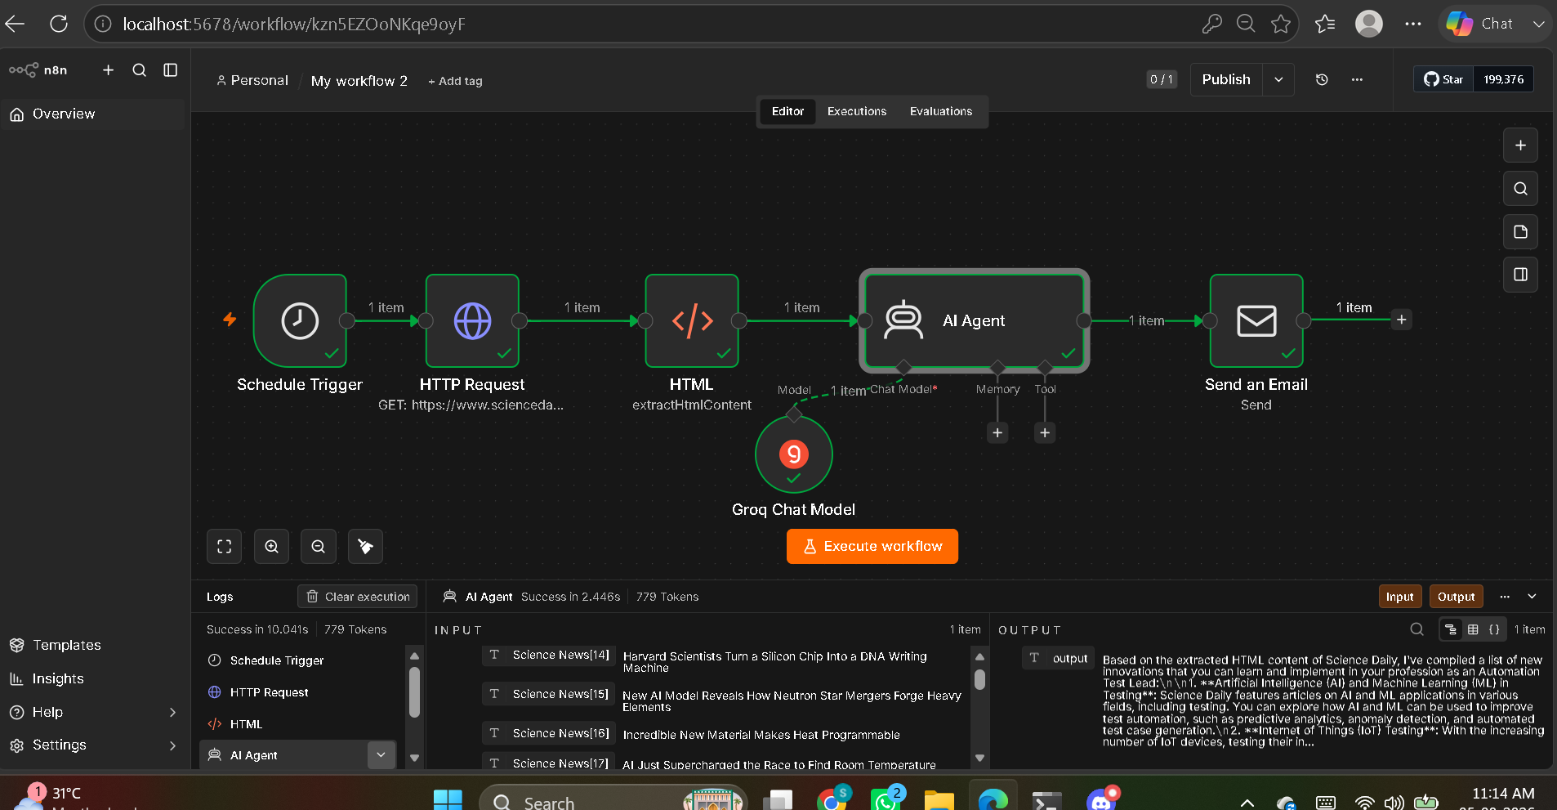

Prompt given in AI agent –

I'm working in IT industry as an Automation test lead. From the extracted HTML content of science daily page, give me the list of new innovations which i can learn and implement in my profession.{{ $json.Sciencenews }} . [STRICT] List down the innovation news which is appropriate and then give suggestions below only as per the content of the new innovation news, don't give suggestions apart from the new innovation news.

Email Output :

